# CELL CYCLE

Cell cycle can be defined as the entire sequence of events happening from the end of one nuclear division to the beginning of the next. A cell cycle consists of two phases, v*iz*., 1) interphase and 2) the cell division proper. The time required for the completion of cell cycle differs from species to species.

## Interphase

Interphase is generally known as DNA systhesis phase. Interphase consists of G1, S and G2 sub phases. G1 is the resting phase, S is the period of DNA replication and G2 again is a resting stage after DNA replication.

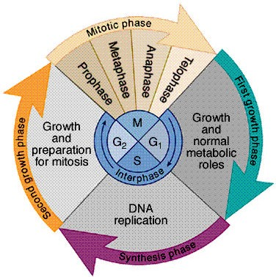

**G1 Phase:** It is a pre-DNA replication phase. Thus, this is a phase between telophase and S phase. This is the longest phase which takes 12 hours in *Vicia faba*. It is the most variable period of cell cycle. Synthesis of proteins and RNA take place during this phase.

**S (Synthetic) Phase:** This phase comes after G1and takes lesser time than

G1phase. In *Vicia faba*, it takes six hours. The chromosome and DNA replications take place during this phase.

**G2 Phase:** This is the post-DNA replication phase and last sub stage of interphase. This phase also takes 12 hours in *Vicia faba*. Synthesis of protein and RNA occur during this stage.

## CELL DIVISION

All the cells are produced by division of pre-existing cells. Continuity of life depends on cell division. In the cell division, the division of nucleus is called

karyokinesis and division of cytoplasm is called cytokinesis. The cell division is of two types. 1) Mitosis and 2) Meiosis

## MITOSIS

The term mitosis was coined by Flemming in 1882. Mitosis occurs in somatic organs like root tip, stem tip and leaf base etc. Hence it is also known as somatic cell division. The daughter cells are similar to the mother cell in shape, size and chromosome complement. Since the chromosome number is same in the daughter cells as compared to that of mother cell, this is also known as homotypic or equational division.

Mitotic cell cycle includes the following stages:

**Interphase :** This is the period between two successive divisions. Cells in interphase are characterized by deeply stained nucleus that shows a definite number of nucleoli. The chromosomes are not individually distinguishable but

appear as extremely thin coiled threads forming a faintly staining network. The cell is quite active metabolically during interphase.

## Mitosis consist of four stage, *viz.,* (a) Prophase, (b) Metaphase, (c)

**Anaphase and (d) Telophase**

## Prophase: The nucleus takes a dark colour with nuclear specific stains and also with acetocarmine / orcein. The size of the nucleus is comparatively big and the chromosomes that are thin in the initial stages slowly thicken and shorten by a specific process of coiling. The two chromatids of a chromosome are distinct with matrix coating and relational coiling. The disinte gration of nuclear membrane denotes the end of prophase.

1. Metaphase: **After the disintegration of nuclear membrane, the shorter and thicker chromosomes will spread all over the cytoplasm. Later, the size of the chromosomes is further reduced and thickened. T he distinct centromere of each chromosome is connected to the poles through spindle fibres. The chromosomes move towards equator and the centromere of each chromosome is arranged on the equator. This type of orientation of centromeres on the equator is known as auto - orientation. The chromosomes at this stage are shortest and thickest. The chromatids of a chromosome are held together at the point of centromeres and the relational coils are at its minimum.**

## Anaphase: The centromere of each chromosome separates first and moves to towards the poles. Depending on the position of the centromeres (metacentric, acrocentric and telocentric), the chromosomes show ` V `, ` L ` and ` I ` shapes respectively as the anaphase progresses. The sister chromatids move to the poles. The chromosome number is constant but the quantity of each chromosome is reduced to half.

1. Telophase: **Chromosomes loose their identity and become a mass of chromatin. The nucleus will be re-organized from the chromatin. At late telophase stage, the cell plate will divide the cell into two daughter cells.**

## Cytokinesis : The division of cytoplasm usually occursbetween late anaphase and end of telophase . In plants, cytokinesis takes place through the formation of cell plate, which begins in the centre of the cell and moves towards the periphery in both sides dividing the cytoplasm into two daughter cells. In animal cells, cytokinesis occurs by a process known as cleavage, forming a cleavage furrow.

**Significance of Mitosis**

Mitosis plays an important role in the life of living organisms in various ways as given below:

1. Mitosis is responsible for development of a zygote into adult organism after the fusion of male and female gametes.
2. Mitosis is essential for normal growth and development of living organisms. It gives a definite shape to a specific organism.
3. In plants, mitosis leads to formation of new organs like roots, leaves, stems

and branches. It also helps in repairing of damaged parts.

1. It acts as a repair mechanism by replacing the old, decayed and dead cells and thus it helps to overcome ageing of the cells.
2. It helps in asexual propagation of vegetatively propagated crops like sugarcane, banana, sweet potato, potato, etc. mitosis leads to production of identical progeny in such crops.
3. Mitosis is useful in maintaining the purity of types because it leads to production of identical daughter cells and does not allow segregation and recombination to occur.
4. In animals, it helps in continuous replacement of old tissue with new ones, such as gut epithelium and blood cells.

# MITOSIS

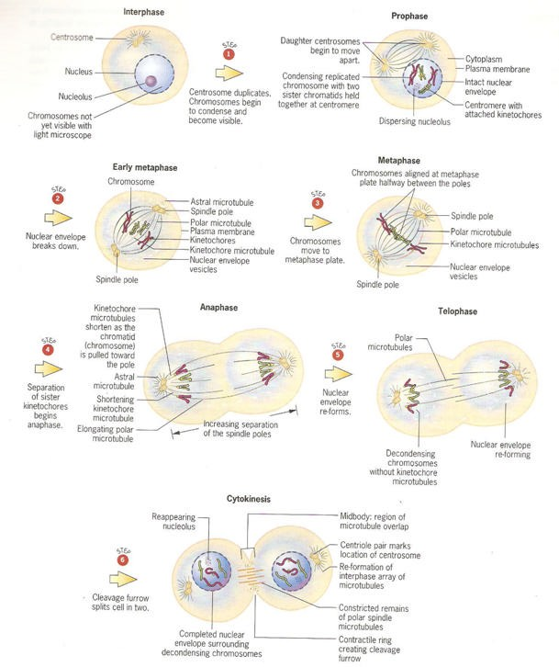

# MEIOSIS

The term meiosis was coined by J.B. Farmer in 1905. This type of division is found in organisms in which there is sexual reproduction. The term has been derived from Greek word; Meioum = diminish or reduce. The cells that undergo meiosis are called meiocytes. Three important processes that occur during meiosis are:

1. Pairing of homologous chromosomes (synapsis)
2. Formation of chiasmata and crossing over
3. Segregation of homologous chromosomes

The first division of meiosis results in reduction of chromosome number to half and is called reduction division. The first meiotic division is also called heterotypic division. Two haploid cells are produced at the end of first meiotic division and in the second meiotic division, the haploid cells divide mitotically and results in the production of four daughter cells (tetrad), each with haploid number of chromosomes. In a tetrad, two daughter cells will be of parental types and the remaining two will be recombinant types. The second meiotic division is also known as homotypic division. Both the meiotic divisions occur continuously and each includes the usual stages *viz.,* prophase, metaphase, anaphase and telophase.

Meiotic cell cycle involves the following stages:

**Interphase :** Meiosis starts after an interphase which is not very different from that of an intermitotic interphase. During the premeiotic interphase DNA duplication occurs during the S phase

## Meiosis-I:

1. **Prophase -I:** It is of a very long duration and is also very complex. It has been divided into the following sub-stages:
   1. **Leptotene or Leptonema:** Chromosomes at this stage appear as long

thread like structures that are loosely interwoven. In some species, on these chromosomes, bead-like structures called chromomeres are found all along the length of the chromosomes.

* 1. **Zygotene or Zygonema:** It is characterized by pairing of homologous chromosomes (synapsis ), which form bivalents. The paired homologous

chromosomes are joined by a protein containing frame work known as synaptonemal complex. The bivalents have four strands

* 1. **Pachytene or Pachynema:** The chromosomes appear as thickened

thread-like structures. At this stage, exchange of segments between non- sister chromatids of homologous chromosomes known as crossing over occurs. During crossing over, only one chromatid from each of the two homologous chromosomes takes part. The nucleolus still persists.

## Diplotene or Diplonema: At this stage further thickening and shortening of chromosomes takes place. Homologous chromosomes start separating from one another. Separation starts at the centromere and travels towards the ends (terminalization). Homologous chromosomes are held together only at certain points along the length. Such points of contact are known as chiasmata and represent the places of crossing over. The process of terminalization is completed at this stage.

* 1. Diakinesis: **Chromosomes continue to undergo further contraction. The bivalents appear as round darkly stained bodies and they are evenly distributed throughout the cell. The nuclear membrane and nucleolus disappear.**

## Metaphase-I: The chromosomes are most condensed and have smooth outlines. The centromeres of a bivalent are connected to the poles through the spindle fibres. The bivalents will migrate to the equator before they disperse to the poles. The centromeres of the bivalents are arranged on either side of the equator and this type of orientation is called co-orientation.

1. Anaphase-I: **The chromosomes in a bivalent move to opposite poles (disjunction). Each chromosome possess two chromatids. The centromere is the first to move to the pole. Each pole has a haploid number of chromosomes**

## Telophase-I: Nuclear membranes are formed around the groups of chromosomes at the two poles. The nucleus and nucleolus are re - organized.

1. **Meiosis-II:** The second meiotic division is similar to the mitotic division and it includes the following four stages:
   1. **Prophase-II:** The chromosomes condense again. The nucleolus and nuclear membrane disappear. The chromosomes with two chromatids each become short and thick
   2. **Metaphase -II:** Spindle fibres appear and the chromosomes get arranged on the equatorial plane(auto-orientation). This plane is at right angle to the equatorial plane of the first meiotic division.
   3. **Anaphase-II:** Each centromere divides and separates the two chromatids,

which move towards the opposite poles.

* 1. **Telophase-II:** The chromatids move to the opposite poles The nuclear envelope and the nucleolus reappears. Thus at each pole, there is re - organization of haploid nucleus.

**Cytokinesis:** The division of cytoplasm takes place by cell plate method in plants and by furrow method in animals. The cytokinesis may take place after meiosis I and meiosis **I** separately or sometimes may take place at the end of meiosis II only.

## Significance of Meiosis

Meiosis plays a very important role in the biological populations in various ways as given below:

1. It helps in maintaining a definite and constant number of chromosomes in a

species.

1. Meiosis results in production of gametes with haploid (half) chromosome number. Union of male and female gametes leads to formation of zygote which receives half chromosome number from male gamete and half from the female gamete and thus the original somatic chromosome number is restored.
2. Meiosis facilitates segregation and independent assortment of chromosomes and genes.
3. It provides an opportunity for the exchange of genes through the process of crossing over. Recombination of genes results in generation of variability in a biological population which is important from evolution points of view.
4. In sexually reproducing species, meiosis is essential for the continuity of generation. Because meiosis results in the formation of male and female

gametes and union of such gametes leads to the development of zygotes and thereby new individual.

# MEIOSIS

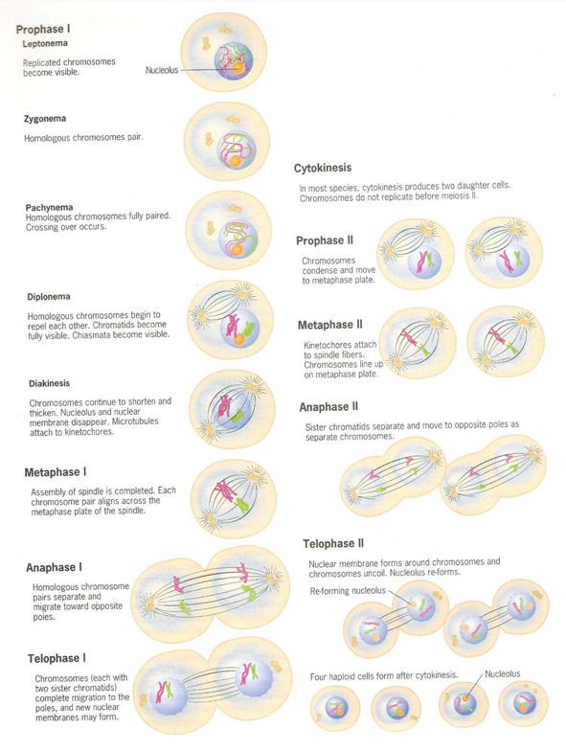

## Differences between mitosis and meiosis

|  |  |
| --- | --- |
| **Mitosis** | **Meiosis** |
| 1. Consists of one nuclear division | 1. Consists of two nuclear divisions |
| 2. One cell cycle results in production of two daughter cells | 2. One cell cycle results in production of four daughter cells |
| 3. The chromosome number of daughter cells is the same as that of mother cell (2n) | 3. Daughter cells contain half the chromosome number of mother cell (n) |
| 4. Daughter cells are identical with mother cell in structure and chromosome composition | 4. Daughter cells are different from mother cell in chromosome number and composition |
| 5. It occurs in somatic cells | 5. It occurs in reproductive cells |
| 6. Total DNA of nucleus replicates during S phase | 6. About 0.3% of the DNA is not replicated during S phase and it occurs during the zygotene stage. |
| 7. The prophase is not divided into sub stages | 7. The prophase I is divided into five sub stages |
| 8. There is no pairing between homologous chromosomes | 8. Homologous chromosomes pair during pachytene |
| 9. Segregation and recombination do not occur | 9. Crossing over takes place during pachytene |
| 10. Chromosomes are in the form of dyad at metaphase | 10. Chromosomes are in the form of tetrad at metaphase |
| 11. The centromeres of all the chromosomes lie on the equatorial plate (auto orientation) during metaphase | 11. The centromeres of all the chromosomes lie on either side of the equatorial plate (co-orientation) during metaphase I |
| 12. At metaphase, centromere of each bivalent divides longitudinally | 12. The centromere does not divide at metaphase I |
| 13. One member of sister chromatids moves to opposite pole during anaphase | 13. One member of homologous chromosomes moves to opposite poles during the anaphase I |
| 14. Maintains purity due to lack of segregation and recombination | 14. Generates variability due to segregation and recombination |